DAT 530 uCertify Lab Activity Worksheet

Module Labs
- 3.4.1 Creating Base Static Plot for Interactive Data Visualization
- 3.4.2 Adding a Slider to the Static Plot
- 3.4.3 Adding a Hover Tool to a Scatterplot Using Bokeh
- 3.4.4 Creating an Interactive Scatterplot

Lab Screenshots
- 3.4.1 Creating Base Static Plot for Interactive Data Visualization
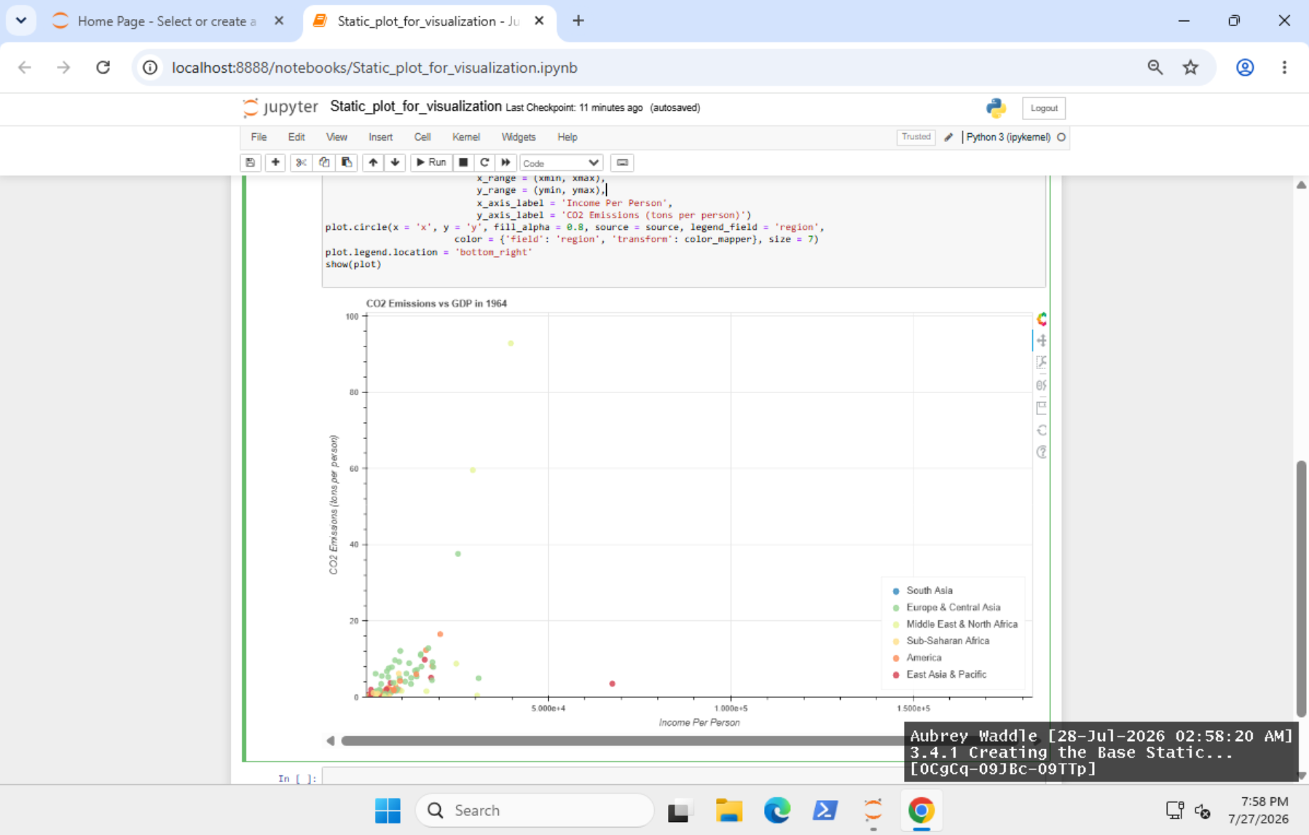
- 3.4.2 Adding a Slider to the Static Plot
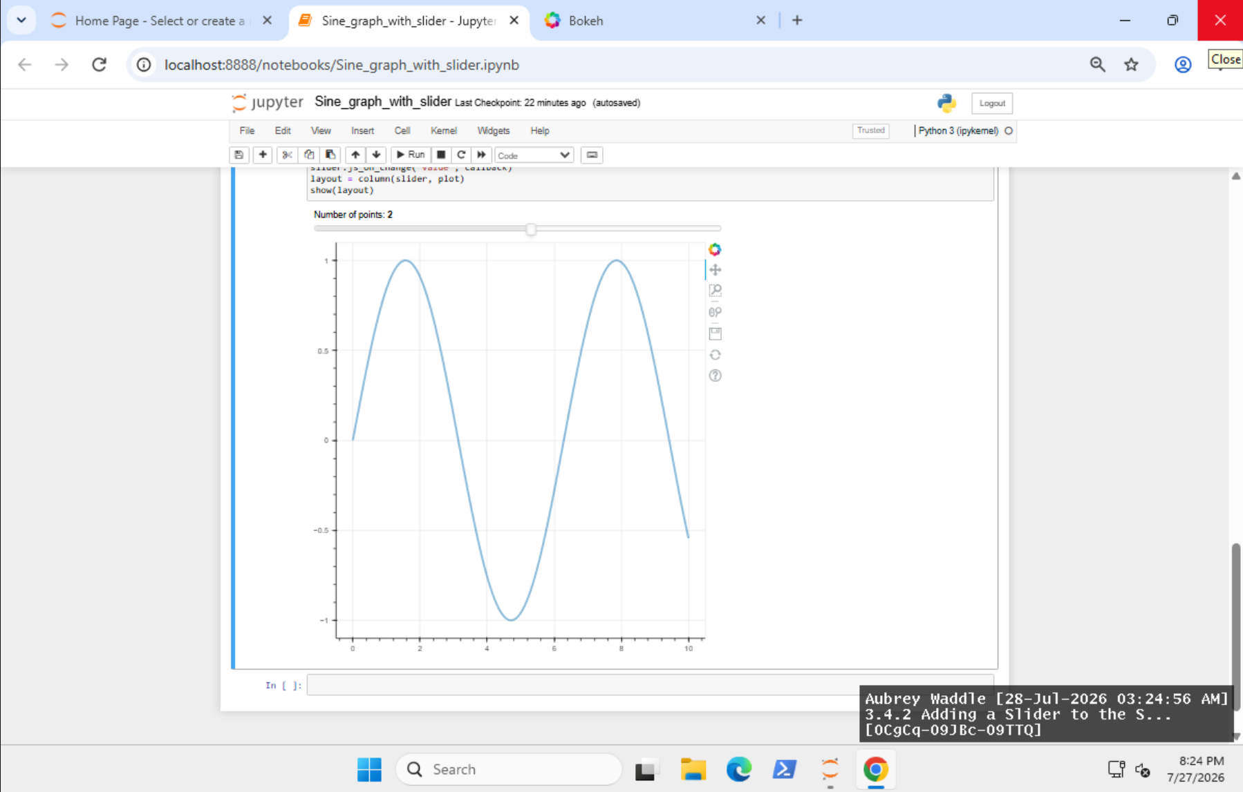
- 3.4.3 Adding a Hover Tool to a Scatterplot Using Bokeh
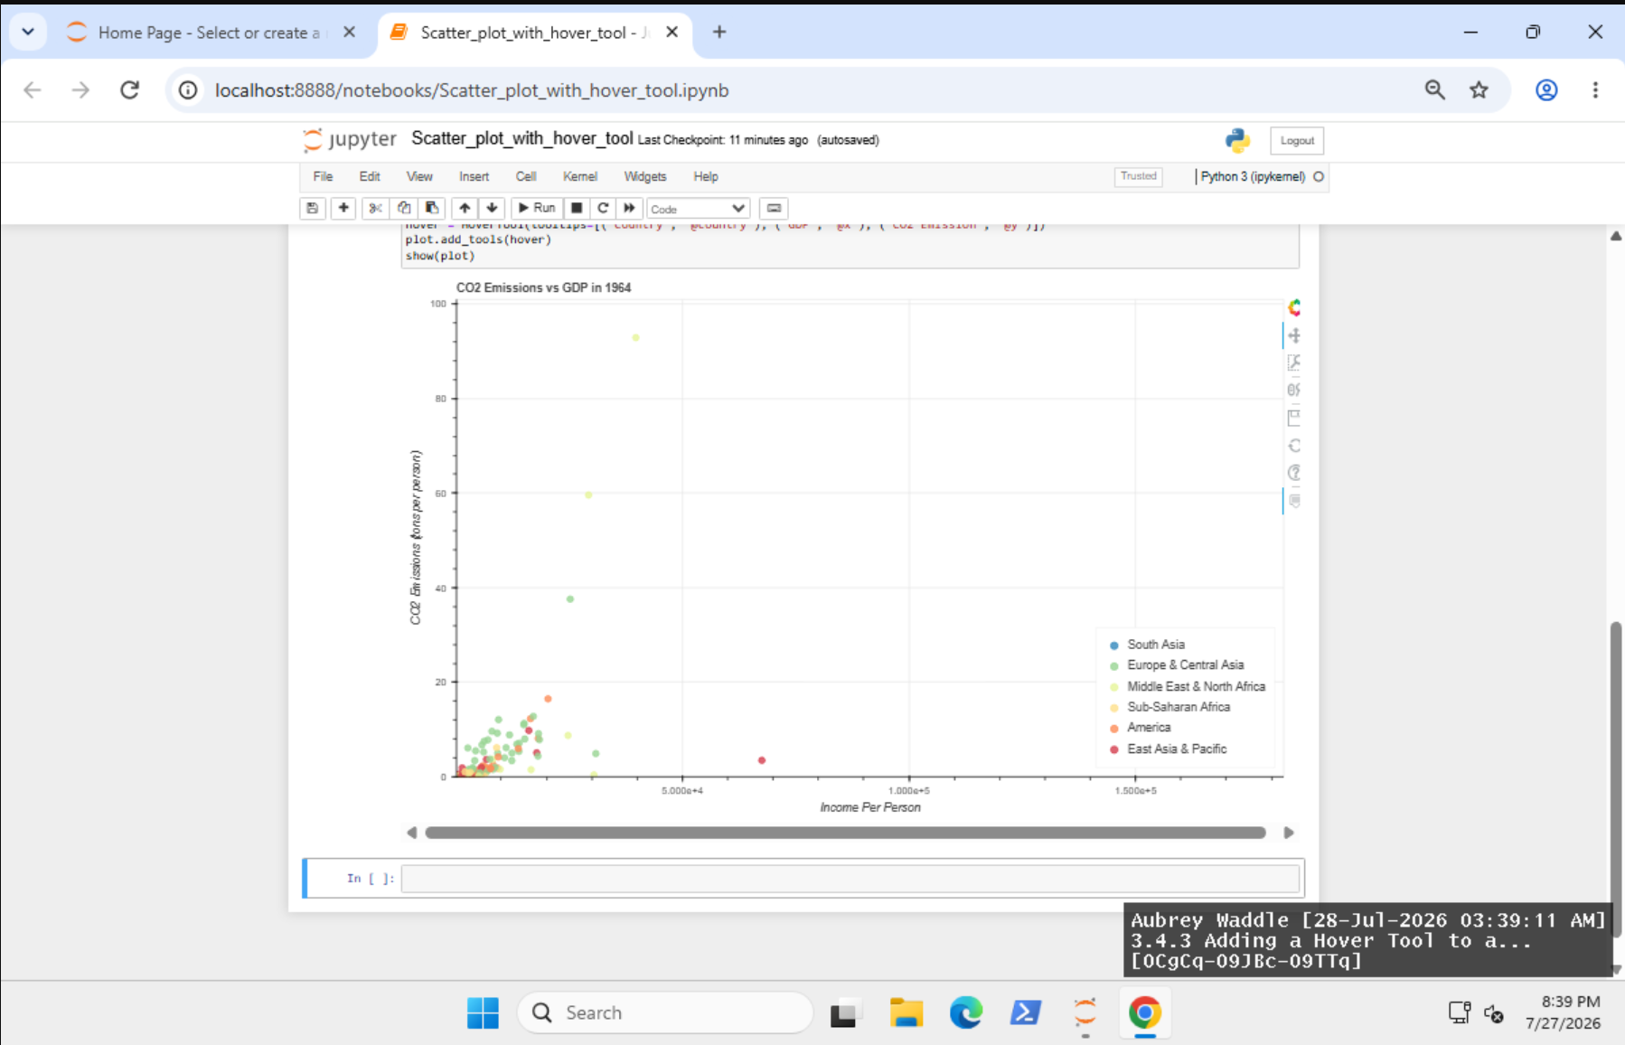

- 3.4.4 Creating an Interactive Scatterplot
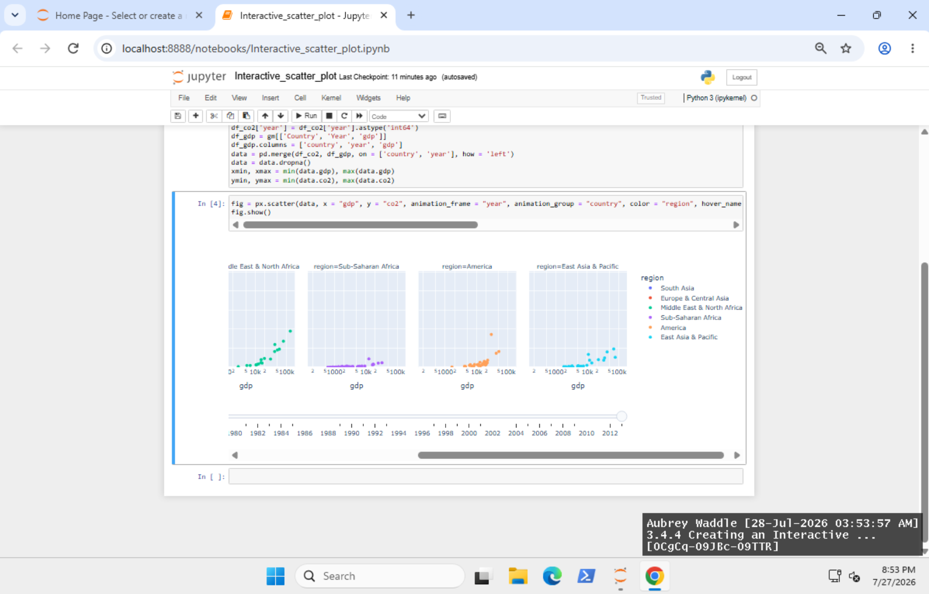

Lab Reflection

- 3.4.1 Creating Base Static Plot for Interactive Data Visualization
In this lab I used Bokeh to make a static scatter plot of each countries GDP per capita and CO2 emissions. For the scatter plot we used plot.circle(), a CategoricalColorMapper to color the points by area, and a ColumnDataSource for the data. Unlike the static visualizations we generated earlier in the course using Seaborn, Bokeh has built-in interactivity and can create high quality graphics for publication. This style is particularly useful for analysts and policy makers who need to differentiate between categories while analyzing correlations between variables.

- 3.4.2 Adding a Slider to the Static Plot
For this lab I used the Bokeh Slider() widget and CustomJS() callback to create an interactive sine wave. As the slider moved the callback updated the yvalues in real time demonstrating how visualizations may be made interactive with JavaScript without the need to restart Python code. The focus here was to provide the user direct control over the display, rather than evaluating a data set as in the last lab. Interactive charts like these are useful for dashboards and teaching aids where users may modify parameters themselves.

- 3.4.3 Adding a Hover Tool to a Scatterplot Using Bokeh
So I could increase the size of the Bokeh scatter plot by connecting a HoverTool() instance to it using plot.add_tools(hover). You may hover your cursor over a country to get further information about it – like its GDP and CO2 emissions. This considerably increased the informativeness of the representation, without flooding the graph with permanent labels. Interactive tooltips are a godsend for analysts and business users who want to drill down into specific results and still keep the presentation clean and accessible.
- 3.4.4 Creating an Interactive Scatterplot
For this lab I created an animated scatter plot using Plotly Express and px.scatter(). In the graphic I used elements like animation_frame, animation_group, facet_col and hover_name to highlight the time-series variations in GDP and CO_2 emissions, and the clustering of different regions. With Plotly it was easier to make interactive animations, with less code, than the visualizations in Bokeh. This is a great visualization for presentations and for executive audiences since it displays changes over time in a fascinating and easy-to-understand way.

